Online Grocery System

Author : Mohamed Thaiseer

**Overview**

This document details about online store, user shopping, checkout, discount and bill generation

**Functional requirement**

* Customer can login to online store
* Customer select new cart
* Customer add or remove Products to cart
* Customer proceed to checkout
* Store calculate discount and generate invoice
* Customer make payment
* Customer select logout

**Assumptions**

* database and related operations are out-of-scope
* UI components are out-of-scope
* payment and proceeding are out-of-scope
* session management is out of scope

**User stories**

* As a user, I want to login to store, so I can be a member
* As a member, I want to add or remove Items to my cart
* As a member, I want to checkout, so discount will be applied and generate bill

**Usecase Diagram**

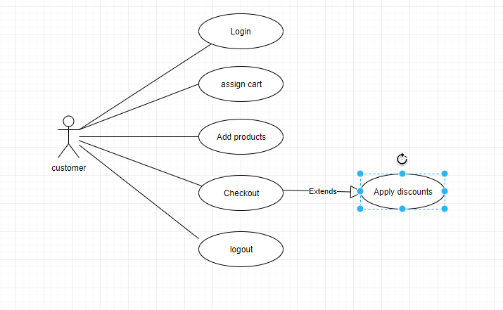

Class Diagram

